MALTZ JUPITER THEATRE PRESENTS CLOSE-UP MAGICIAN AND MENTALIST, DENNIS WATKINS’ THE MAGIC PARLOUR
This acclaimed Chicago-based magician and mentalist brings mystery and artistry to the intimate Second Space, The Island Theatre.
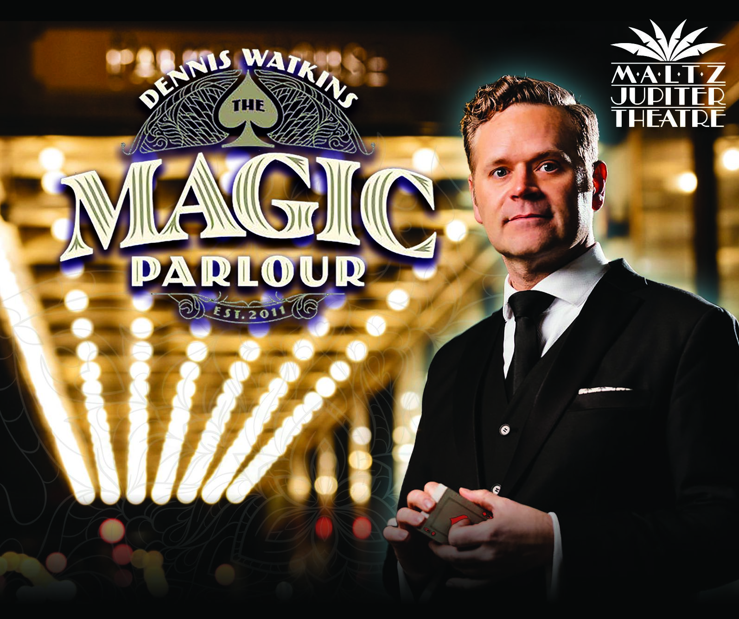
FOR IMMEDIATE RELEASE - December 16, 2024 (Jupiter, FL) – The Maltz Jupiter Theatre is proud to announce a captivating new addition to its entertainment offerings: Dennis Watkins' Magic Parlour (January 2-5, 2025). This intimate close-up magic experience will take place in the Theatre's newly unveiled Second Space, The Island Theatre.
Dennis Watkins, a third-generation magician and mentalist, is bringing his highly acclaimed show from Chicago to Jupiter for a limited engagement of five performances. For over a decade, Watkins has mesmerized audiences at The Palmer House Hilton Hotel in the heart of downtown Chicago with his unique blend of magic, mentalism, and storytelling.
Growing up in a family steeped in magic, Watkins' passion for the art was ignited at an early age. His grandfather, a close-up magician who owned a magic shop in Dallas, TX for nearly 30 years, instilled in him the belief that magic is not about deception, but rather about inspiring wonder and igniting the imagination.
"My grandfather taught me that the true purpose of magic is to help people reconnect with the sense of wonder they had as children," says Watkins. "That's what I strive to do with every performance."
Watkins' captivating performances have earned him a devoted following and critical acclaim. He has showcased his extraordinary talents at prestigious venues such as the Magic Castle in Hollywood and the Chicago Magic Lounge, and has made numerous television appearances, including a memorable performance on Penn and Teller's Fool Me.
"We are thrilled to bring this innovative show to our audiences. We recommend telling friends and family to stay in town during the first week of the new year to catch Dennis Watkins’ The Magic Parlour, " says Andrew Kato, Producing Artistic Director and Chief Executive at the Maltz Jupiter Theatre, "Tickets to this event also make for a perfect holiday gift to loved ones.”
Dennis Watkins' Magic Parlour will surely provide an unforgettable evening for our patrons.”
The Island Theatre's intimate atmosphere provides the perfect setting for Watkins' astonishing illusions and interactive performance style. The seating arrangement, with a mix of gallery seating and premium cabaret tables, ensures that every guest has an up-close view of the magic.
"I want the audience to be fully immersed in the experience," says Watkins. "In a smaller, more intimate setting, the magic becomes even more powerful and personal."
Whether you're a seasoned magic enthusiast or simply seeking a unique and memorable evening, Dennis Watkins' Magic Parlour is sure to leave you spellbound.
Ticket Information
Individual tickets to Dennis Watkins’ The Magic Parlour are on sale now, starting at $60 per ticket for gallery seating and $75 for premium table seats. Single and premium seat tickets can be purchased on the Theatre’s website at: jupitertheatre.org or by contacting the Box Office at: (561) 575-2223. The Box Office is open weekdays between 10 am - 6 pm and Saturdays from 10 am - 2 pm.
Coming Up Next at Maltz Jupiter Theatre:
The MainStage Theatre:
The first show of the 2025 new year kicks off with Disney’s Frozen, The Broadway Musical (January 7th - 26th). Running in tandem with the show is The Blizzard Experience in which The Island Theatre will be transformed into a winter wonderland. This offering is free and welcome to any ticket holders during the run of Frozen. Following that is The Lehman Trilogy (February 16th - March 2nd) on the MainStage with a riveting story of the rise and downfall of a financial dynasty.
In the 659-seat MainStage Theatre, we will be hosting an exciting lineup of Limited Engagement performances starting in January, including The Beat Goes On (January 28th: 7:30pm), Meet Loaf (January 30th: 7:30pm), Here Comes the Sun: The Music of the Beatles (January 31st: 7:30pm), George Michael Reborn: The #1 Tribute to George Michael and WHAM (February 1st: 8pm), Yellow Brick Road (February 5th: 5pm,7:30pm), The Drifters (February 6th: 7:30pm), So Good! The Neil Diamond Experience: Starring Robert Neary (February 7th: 5pm,7:30pm), David Clark Presents Live at the Garden: The Music of Billy Joel (February 8th: 8pm), A Tribute to Dolly (March 4th: 7:30pm), Stayin' Alive - One Night of the Bee Gees (March 5th: 7:30pm), How Sweet It Is! Steve Leslie sings James Taylor (March 6th: 7:30pm), and Forever Motown (March 7th: 5pm, 7:30pm).
The Island Theatre:
The new 198-seat, flex-space, Island Theatre will also host a wide variety of Limited Engagements. In February, we offer our unique “Cabaret Series,” including Bette Midler: Bathhouse to Broadway (February 12th-13th: 5pm, 8pm), Amore! Starring Anthony Nunziata (February 14th: 5pm, 8pm), Somewhere Between Jazz, Blues, and You: An Evening with Mikayla Smith (February 15th: 8pm), Love Finds Judy Garland (March 14th: 5pm, 8pm), and Show Stoppers! Starring Avery Sommers (March 15th: 8pm)
Our final play in The Island Theatre will be Who’s Afraid of Virginia Woolf (April 22nd - May 4th), the renowned comedy drama and American classic by Edward Albee.
About the Maltz Jupiter Theatre The not-for-profit Maltz Jupiter Theatre has become one of Florida’s preeminent professional regional theatres, committed to production and education through its collaborations with local and national artists. Currently a member of the prestigious League of Resident Theatres, the Maltz Jupiter Theatre draws 100,000 patrons annually, serves a subscription base of more than 7,200, and provides performing arts education to both youth and adult students through its Goldner Conservatory. The Island Theatre, a new 198-seat, Second Space has been added to the Theatre’s newly renovated 62,000 square foot facility for the 2024/25 season. Maltz Jupiter Theatre has earned numerous Carbonell Awards, South Florida’s highest honor for artistic excellence, including the prestigious Bill Von Maurer Award for Theatrical Excellence and The Ruth Foreman Award. For tickets and to learn more about all we offer, visit: www.jupitertheatre.org or contact the Box Office at: (561) 575-2223.

Media Contact:
Miriam Colvin, (561)-781-3038

mcolvin@jupitertheatre.org

