**THE MALTZ JUPITER PRESENTS A RIVETING AND OMINOUS PSYCHOLOGICAL THRILLER, *DECEIVED*: BASED ON PATRICK HAMILTON’S *GASLIGHT.***

The “Extraordinary Journeys” MainStage Season kicks off with a timeless classic, reimagined through a modern lens with adaptations by Johnna Wright and Patty Jamieson

**FOR IMMEDIATE RELEASE**

**October 15th, 2024 (Jupiter, FL) -** The Maltz Jupiter Theatre’s MainStage proudly presents the North American Premiere of ***Deceived*:Based on Patrick Hamilton’s *Gaslight*** (October 27th through November 10th).

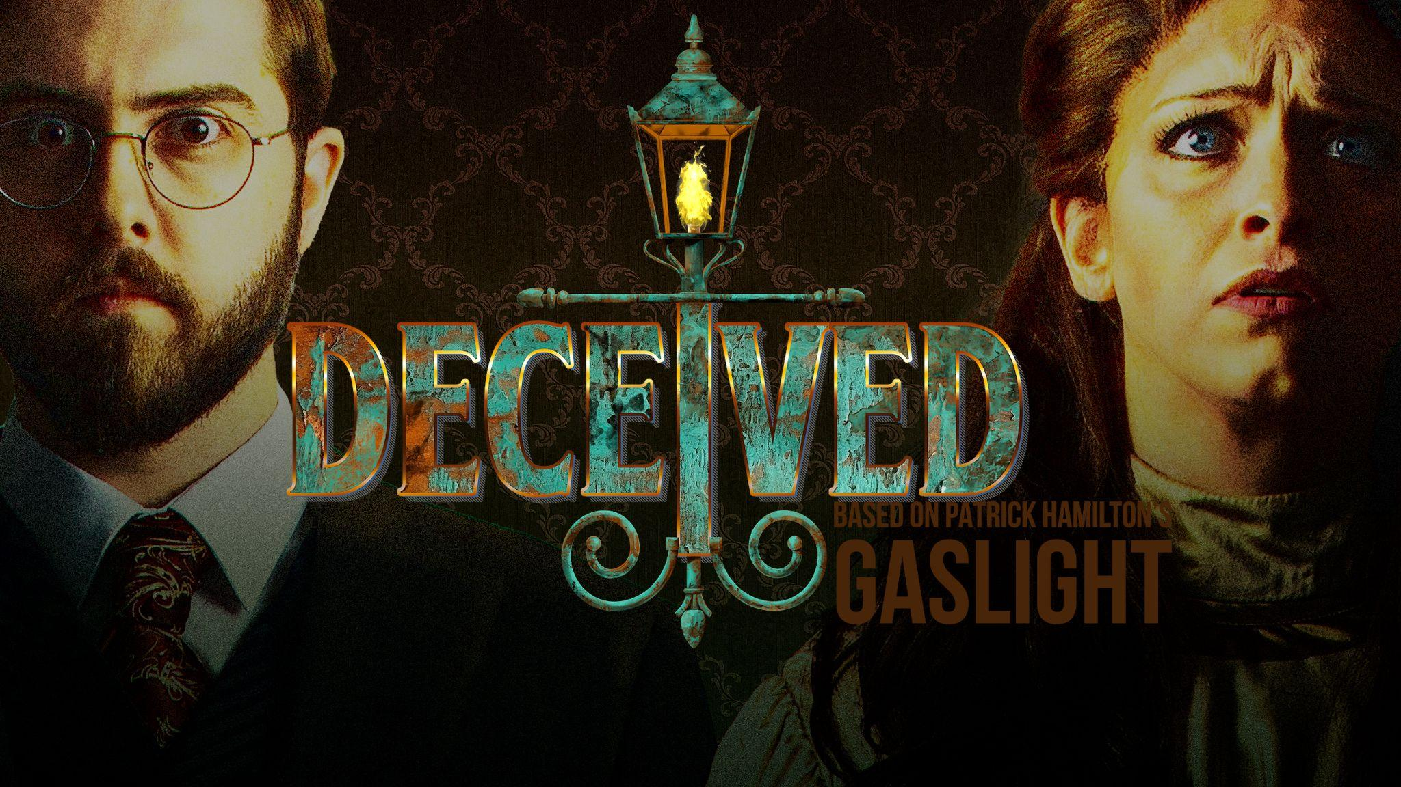

Take a moment, and imagine yourself living in a London Townhouse in 1901 with your attractive and charming new husband. As you settle into domesticity, strange things start occurring around the ornate abode. There are unexplainable noises in the night, and the gaslights around the house keep mysteriously dimming. A feeling of incoming danger inhabits your mind. You share your fears with your handsome other-half, to find reassurance, but he brushes your fears off as silly, and has confident skepticism in the things you find worrisome. ***Deceived****:* **Based on Patrick Hamilton’s *Gaslight*** chronicles the story of one, Bella Manningham, as we witness her psychologically shift right before our eyes.

Following the married couple of **Jack and Bella Manningham**, the play quickly sets a tone that not everything is what it seems, an underlying aura of discomfort and suspense. ***Deceived*** offers an exciting rollercoaster of emotions and plot twists as Bella’s descent into madness seems impossible to overcome. Our particular production is a new adaptation made by Johnna Wright and Patty Jamieson, which premiered at The Shaw Festival in Canada in 2022. In their version, they’ve put the investigative work into the hands of the female protagonist.

**Johnna Wright** says, “We love a good old-fashioned thriller, because to us there is so much richness in that style – gloomy Victorian mansions, danger lurking in the corner, suspenseful music, dramatic reveals. And *Gaslight* has all of that. But in the original, Bella doesn’t really get to help herself. A police inspector knocks on her door, explains what’s been going on, and rescues her. In our version, the situation is the same: Bella is isolated, afraid, and worried that she’s going crazy. But this time there’s no police inspector coming. If she’s going to survive, she’ll have to rescue herself. We had fun imagining what might happen next, and audiences seem to get a lot of satisfaction out of watching Bella try to turn the tables.”

**Patty Jamieson**, continues, “If we think of gaslighting as when someone tells you you’re wrong even though they know you’re right – well, we’ve all been there. We’ve all experienced self-doubt, and we’ve probably all trusted the wrong person at least once or twice. Bella’s story resonated for us in so many ways that we thought it could have meaning for others as well. Still, a lot has changed since 1938, when the original play premiered – including our culture’s assumptions about how women operate and what they are capable of. So we wondered, would it be possible to reimagine *Gaslight* as a story about a woman’s strength and resourcefulness?”

The Patrick Hamilton classic, that some may argue is “dated,” playwrights Wright and Jamieson have provided the story with fresh new eyes, and a more current message for our 2024 audiences. Women aren’t always the victim, they’re not incapable of solving their own problems, and they have the power to rise above abuse and manipulation. It allows us to place ourselves within the story.

Tony-nominated® and Helen Hayes Award-Winning Director, **Marcia Milgrom Dodge,** who will be making her directorial return to the Maltz Jupiter Theatre, says, “In *Angel Street* [the play’s original title], Bella puts her trust in Detective Rough who rescues her from her frightening situation, making him the hero of the story.In this adaptation Bella is our heroine who saves herself, making it a gripping, reimagined thriller of daring and doubt for modern times.”

Set in London, 1901, the play’s set will embody a Victorian style home that feels as though it's nearly a prison itself. Designed by the talented **Michael Schweikardt** (Broadway World Award, Carbonell Award, Connecticut Critics Circle Award, and the Kevin Kline Award), the scenic design offers A *Doll’s House*-esque symbolism, the house nearly caving in, trapping Bella within the confines of her abusive relationship. Lighting Designer, **Amanda Zieve** (2023 Jeff Award

2024 Women to Watch on Broadway , 2024 Outer Critics Circle Nomination) will use light and shadow to promote an ominous feeling and a creeping darkness of the gothic-style residence.

Bella will wear eight different Victorian inspired costumes throughout the show created by the award-winning Costume Designer, **Lex Liang**, who has designed a long list of shows, off-Broadway and internationally. The Creative and Design Team will also include Sound Designer **David Bullard;** Wig Designer **Kevin Foster;** Dialect Coach **Jennifer Burke;** Stage Manager **Kent Collins;** Assistant Stage Manager **Randall Swinton.**

Our Bella, played by **Gaby Tortoledo,** is a Carbonell winner and Florida favorite. She’ll be excitedly welcomed to the Maltz Jupiter Theatre for the first time.The cast also includes **Kevin Earley** as Jack Manningham, **Megan Fulmer** as Nancy, **Jan Neuberger** as Elizabeth, **Kim Cozort Kay** as Understudy for Bella/Elizabeth/Nancy, and **Vince Wingerter** as Understudy for Jack.

Producing Artistic Director and Chief Executive, **Andrew Kato** describes, “The verb, ‘gaslight,’ has become increasingly more popular in modern slang today with Merriam-Webster-Dictionary naming it ‘Word of the Year’ in 2022. This term comes from the play itself, and the way in which Bella is manipulated: her own belief of self is skewed. It was popularized by the 1944 film adaptation starring Ingrid Bergman. Today, this word is often used to describe toxic characters in modern entertainment, as well as the behavior of celebrities or politicians.”

*Gaslight* was published in 1938. Still today, many women have experienced first-hand accounts of “mansplaining” or “gaslighting.” By taking that dismissive misogyny, and implementing it into a daring plot with exciting twists and turns, *Deceived* dramatizes these frustrating feelings of womanhood in a spectacular way. This dark, daring, and evocative thriller will leave you on the edge of your seat at the Maltz Jupiter Theatre’s MainStage theatre. This play takes us on a ride of thrill, mystery, and fear, from beginning to end.

**Ticket Information**

Individual tickets to *Deceived,* based on Patrick Hamilton’s *Gaslight* are on sale now, starting at $50 per ticket, on select performances. Single, club level and premium seat tickets can be purchased on the Theatre’s website at: jupitertheatre.org or by contacting the Box Office at: (561) 575-2223. For group tickets (20 or more), email: sales@jupitertheatre.org. The Box Office is open weekdays between 10 am - 6 pm and Saturdays from 10 am - 2 pm.

**About the Maltz Jupiter Theatre**

The not-for-profit Maltz Jupiter Theatre has become one of Florida’s preeminent professional regional theatres, committed to production and education through its collaborations with local and national artists. Currently a member of the prestigious League of Resident Theatres, the Maltz Jupiter Theatre draws 100,000 patrons annually, serves a subscription base of more than 7,200, and provides performing arts education to both youth and adult students through its Goldner Conservatory. The Island Theatre, a new 198-seat, Second Space has been added to the Theatre’s newly renovated 62,000 square foot facility for the 2024/25 season. Maltz Jupiter Theatre has earned numerous Carbonell Awards, South Florida’s highest honor for artistic excellence, including the prestigious Bill Von Maurer Award for Theatrical Excellence and The Ruth Foreman Award. For tickets and to learn more about all we offer, visit: [www.jupitertheatre.org](https://server.jupitertheatre.org/exchweb/bin/redir.asp?URL=http://www.jupitertheatre.org) or contact the Box Office at: (561) 575-2223.

Media Contact:

Miriam Colvin, (561)-781-3038

[mcolvin@jupitertheatre.org](mailto:mcolvin@jupitertheatre.org)

