**THE FLORIDA PREMIERE OF *DISNEY’S FROZEN, THE BROADWAY MUSICAL* COMES THIS JANUARY*.***

A once-in-a-lifetime opportunity to see this show at the largest regional theatre in the southern half of the United States.

**FOR IMMEDIATE RELEASE Dec. 17, 2024 (Jupiter, FL)** – The Maltz Jupiter Theatre is thrilled to announce the Florida Premiere of***Disney's Frozen, The Broadway Musical*** (January 7-26, 2025). Our Theatre was one of only eight theatres to be contacted by Disney Theatrical and Music Theatre International to initially produce regional premieres of *Disney’s Frozen, The Broadway Musical.* Many families are familiar with the movie, or have at least heard their kids belting out “Let it Go” for hours on end, but this is a once in a lifetime opportunity to see this story fully realized and truly brought to life. This production will feature dazzling costumes, stunning scenery, all the iconic songs from the film, as well as new music written exclusively for the stage. This enchanting production will bring Disney’s beloved story of sisterhood, love, and acceptance to life on stage, captivating audiences whether young or old.

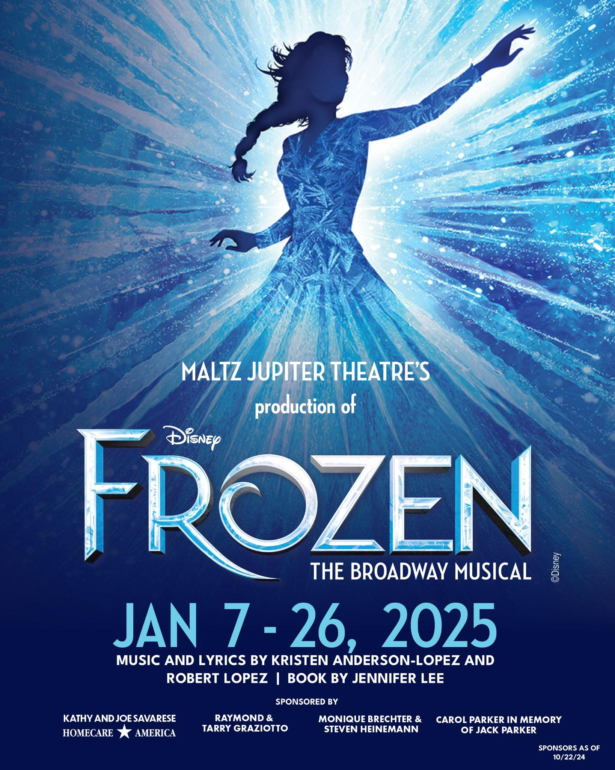

"*Disney’s Frozen, The Broadway Musical* is a story that resonates with people of all ages. We are so excited to bring this magical production to our community and surprise those unfamiliar with the show through the whimsy of our storytelling," said **Andrew Kato**, Producing Artistic Director and Chief Executive of the Maltz Jupiter Theatre.

*Disney's Frozen, The Broadway Musical*, [with music and lyrics by Kristen Anderson-Lopez and Robert Lopez, and book by Jennifer Lee, premiered on Broadway in March 2018](https://www.theatrecriticism.com/disneys-frozen-universal-message-and-impressive-visual-effects/). Nominated for the Tony Award® for Best Musical, Best Original Score, and Best Book of a Musical, the show's success led to multiple international productions, enchanting audiences worldwide with its heartwarming story and unforgettable music.

Director **John Tartaglia** is aTony Award® nominee for his performance in *Avenue Q* on Broadway and three-time Emmy Award® Nominee for his performances in *Splash and Bubbles* and *Johnny and the Sprites.* Tartaglia is no stranger to puppetry, lending perfectly to the larger-than-life puppets used in this production’s storytelling. He is also a master of balancing reality and fantasy when approaching the very real themes of human connection and betrayal within the magical realm of Arendelle.

The show-stopping cast features **Tristen Buettel** a**s** Elsa, **Brooke Quintana** asAnna, **Justin Showell** as Kristoff, **Wesley Slade** asOlaf, and **Dan Hoy** a**s** Hans. Featured in the ensemble cast, and in select roles, is **Giorgio Volpe**, **Brian Klimowski**, **Aaron Patrick Craven**, **Laura McKenna**, **Rachel Hope Ihasz**, **Darrell T. Joe**, **Cecilia Snow**, **Whitney Grace Smith**, **Whitney Renee**, **Larry Toyter**, **Cat Pagano**, **Emily Van Vliet Perea**, **Kristi Rose Mills**, **Bryce Bayer**,and **Alina Pimentel.**

The unforgettable soundtrack will be led by Music Director **Eric Alsford**, as the large cast and ensemble will wow you with choreography by **Kristyn Pope**.The stunning balance between traditional Scandinavian garb and the elegant other-worldly costumes are created by Costume Designer **Leon Dobkowski**. Lighting Designer **Rob Denton** will bring the winter wonderland right to you, while Projection Designer **Lisa Renkel** and Sound Designer **Scott Stauffer** will fully immerse you into the distant land of Arendelle. None of this could be done without Video Programmer **Colin Scott**, Wig Designer **Kevin Foster**,Stage Manager **Kent Collins**, and Assistant Stage Managers **Randall Swinton**, and **Grace Cirillo**.

Maltz Jupiter Theatre brings forth the Disney magic by the grand scale of technical elements you’ll see on our MainStage. So grand, in fact, that the Production Team began working on this set over the summer, which paints a picture of just how intricatethis set really is. The enormous set transforms between worlds, designed by **Tijana Bjelejec**, features a giant LED screen that frames the proscenium arch. **Bjelejec** says, “The set design for this show is ambitious, featuring a large setup with numerous scene changes and special effects. Despite the complexity and scale of the project, the process has been remarkably smooth, thanks to the exceptional teamwork and professionalism of everyone involved.” 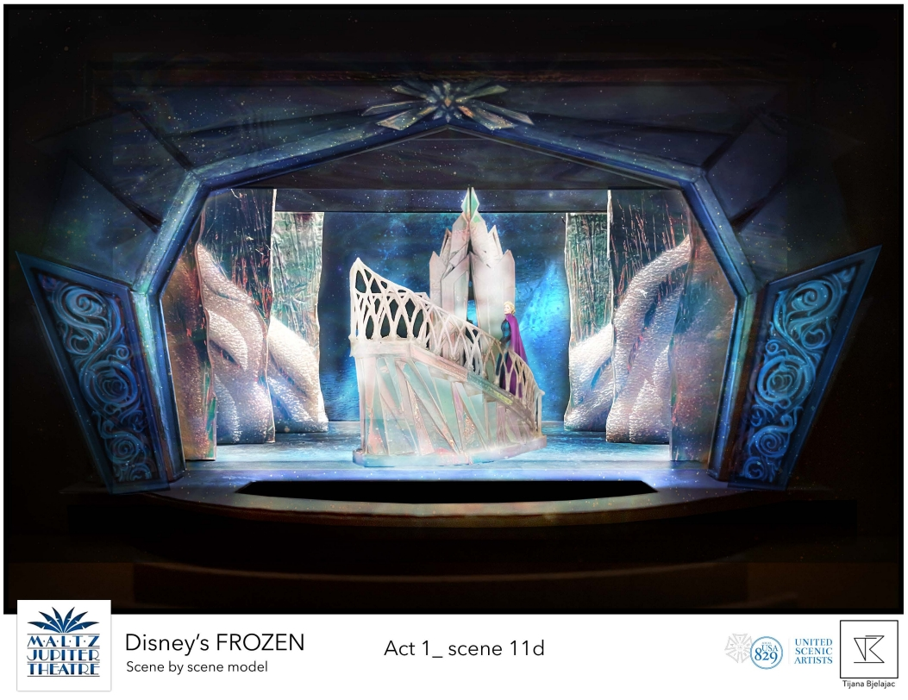

**COURTESY OF TIJANA BJELEJEC //** Scenic Rendering for Act I Scene 11

She continues, “The design elements, such as the contrast between the cold isolation of Elsa’s Ice Palace and the warm, vibrant world of Arendelle, visually reinforce the themes of sisterhood and personal growth. As the story unfolds the two worlds merge together.”

Puppet Designer **Eric Wright**, of Puppet Kitchen Inc., builds fictional concepts and characters into real, moving beings. You’ll see the beloved characters live and in-person including the adorable Sven, the hilarious Olaf, and other animals and creatures that serve as “backup dancers” along the way. Wright has worked on dozens of theatrical stages, collaborated with Thom Browne during New York and Paris Fashion Week, shown in television programs such as *The Daily Show*, and featured in the film, *IF.* 

Wright says, “Puppetry is important because it is one of the most collaborative performing art forms, it invites you to play along.” He notes that, “the best theatre for young audiences are the ones where young people and grown ups can see themselves in these characters.” He believes that everyone has the chance to enjoy *Disney’s* *Frozen, The Broadway Musical,* so long as they lean in and enjoy the escapism into a new world.

**COURTESY OF ERIC WRIGHT //** Puppet Design for “Sven”

**A Fun Pre-Show Experience**



Though, the fun doesn’t end there. Maltz Jupiter Theatre is bringing the magic to life on a larger scale with The Blizzard Experience. Elsa’s ice magic has transformed the Maltz Jupiter Theatre into a winter wonderland. Step into the Blizzard Experience for selfie photo-ops, unique cocktails, exclusive merchandise, and a cozy winter feeling difficult to find in South Florida. **The chilling, yet inviting, winter wonderland welcomes all during the run of *Disney’s Frozen, The Broadway Musical*. It will be open to ticket-holders ninety minutes before each show (when the theatre opens) and during intermission.**

**Ticket Information**

Individual tickets to *Disney’s Frozen, The Broadway Musical* are on sale now, starting at $50 per ticket, on select performances. Single, club level and premium seat tickets can be purchased on the Theatre’s website at: jupitertheatre.org or by contacting the Box Office at: (561) 575-2223. For group tickets (20 or more), email: sales@jupitertheatre.org. The Box Office is open weekdays between 10 am - 6 pm and Saturdays from 10 am - 2 pm.

* Children under the age of 4 will not be admitted into the theatre.

**UP NEXT**

***The Lehman Trilogy*** (February 16th through March 2nd, 2025)takes the MainStage with a riveting story of the rise and downfall of a financial dynasty. As we transition from the historical drama, we transport back to the Golden Age of musicals with the crowd-favorite, ***Guys & Dolls*** (March 18th through April 6th, 2025). We finalize the season in The Island Theatre, right where it began: ***Who’s Afraid of Virginia Woolf*** (April 22nd through May 4th, 2025) will complete our 2024-25 season, with a Contemporary American Theatre classic.

**LIMITED ENGAGEMENTS**

**The MainStage Theatre:** In the 659-seat MainStage Theatre, we will be hosting an exciting lineup of Limited Engagement performances starting in January, including ***The Beat Goes On***(January 28th: 7:30pm)*,* ***Meet Loaf***(January 30th: 7:30pm)*,* ***Here Comes the Sun: The Music of the Beatles*** (January 31st: 7:30pm)*,* ***George Michael Reborn: The #1 Tribute to George Michael and WHAM*** (February 1st: 8pm)*,* ***Yellow Brick Road*** (February 5th: 5pm,7:30pm)*,* ***The Drifters*** (February 6th: 7:30pm)*,* ***So Good! The Neil Diamond Experience:*** *Starring Robert Neary* (February 7th: 5pm,7:30pm)*,* ***David Clark Presents Live at the Garden: The Music of Billy Joel***(February 8th: 8pm)*,* ***A Tribute to Dolly*** (March 4th: 7:30pm)*,* ***Stayin' Alive - One Night of the Bee Gees***(March 5th: 7:30pm)*,* ***How Sweet It Is! Steve Leslie sings James Taylor***(March 6th: 7:30pm)*,* and ***Forever Motown***(March 7th: 5pm, 7:30pm).

**The Island Theatre:** The new 198-seat, flex-space, Island Theatre will host a wide variety of entertainment. In February, we offer our unique “Cabaret Series,” including***Bette Midler: Bathhouse to Broadway*** *(*February 12th-13th: 5pm, 8pm), ***Amore! Starring Anthony Nunziata*** *(*February 14th: 5pm, 8pm), ***Somewhere Between Jazz, Blues, and You: An Evening with Mikayla Smith* (**February 15th: 8pm), ***Love Finds Judy Garland*** *(*March 14th: 5pm, 8pm), and ***Show Stoppers! Starring Avery Sommers* (**March 15th: 8pm)

**About the Maltz Jupiter Theatre** The not-for-profit Maltz Jupiter Theatre has become one of Florida’s preeminent professional regional theatres, committed to production and education through its collaborations with local and national artists. Currently a member of the prestigious League of Resident Theatres, the Maltz Jupiter Theatre draws 100,000 patrons annually, serves a subscription base of more than 7,200, and provides performing arts education to both youth and adult students through its Goldner Conservatory. The Island Theatre, a new 198-seat, Second Space has been added to the Theatre’s newly renovated 62,000 square foot facility for the 2024/25 season. Maltz Jupiter Theatre has earned numerous Carbonell Awards, South Florida’s highest honor for artistic excellence, including the prestigious Bill Von Maurer Award for Theatrical Excellence and The Ruth Foreman Award. For tickets and to learn more about all we offer, visit: [www.jupitertheatre.org](https://server.jupitertheatre.org/exchweb/bin/redir.asp?URL=http://www.jupitertheatre.org) or contact the Box Office at: (561) 575-2223.

Media Contact:

Miriam Colvin, (561)-781-3038

[mcolvin@jupitertheatre.org](mailto:mcolvin@jupitertheatre.org)