**MALTZ JUPITER THEATRE PRESENTS ITS FINAL 2024/25 MAINSTAGE PRODUCTION WITH *GUYS AND DOLLS***

Considered to be the “Perfect Musical,” *Guys and Dolls* Makes its Return to the MainStage Since the 2005 Production.

**FOR IMMEDIATE RELEASE March 3, 2025 (Jupiter, FL)** The Maltz Jupiter Theatre is thrilled to present its final production of the 2024/25 MainStage Season with the beloved musical *Guys and Dolls* ( March 18 to April 6). This Golden Age classic first premiered on the Broadway stage in 1950, winning the Tony Award® for Best Musical in 1951. Based on a story and characters of Damon Runyon, music and lyrics by Frank Loesser, and book by Jo Swerling and Abe Burrows featuring memorable tunes like “Luck Be A Lady,” “Sit Down You’re Rockin’ the Boat,” and “Adelaide’s Lament.”, *Guys and Dolls*, is argued by many to be the “perfect musical.”

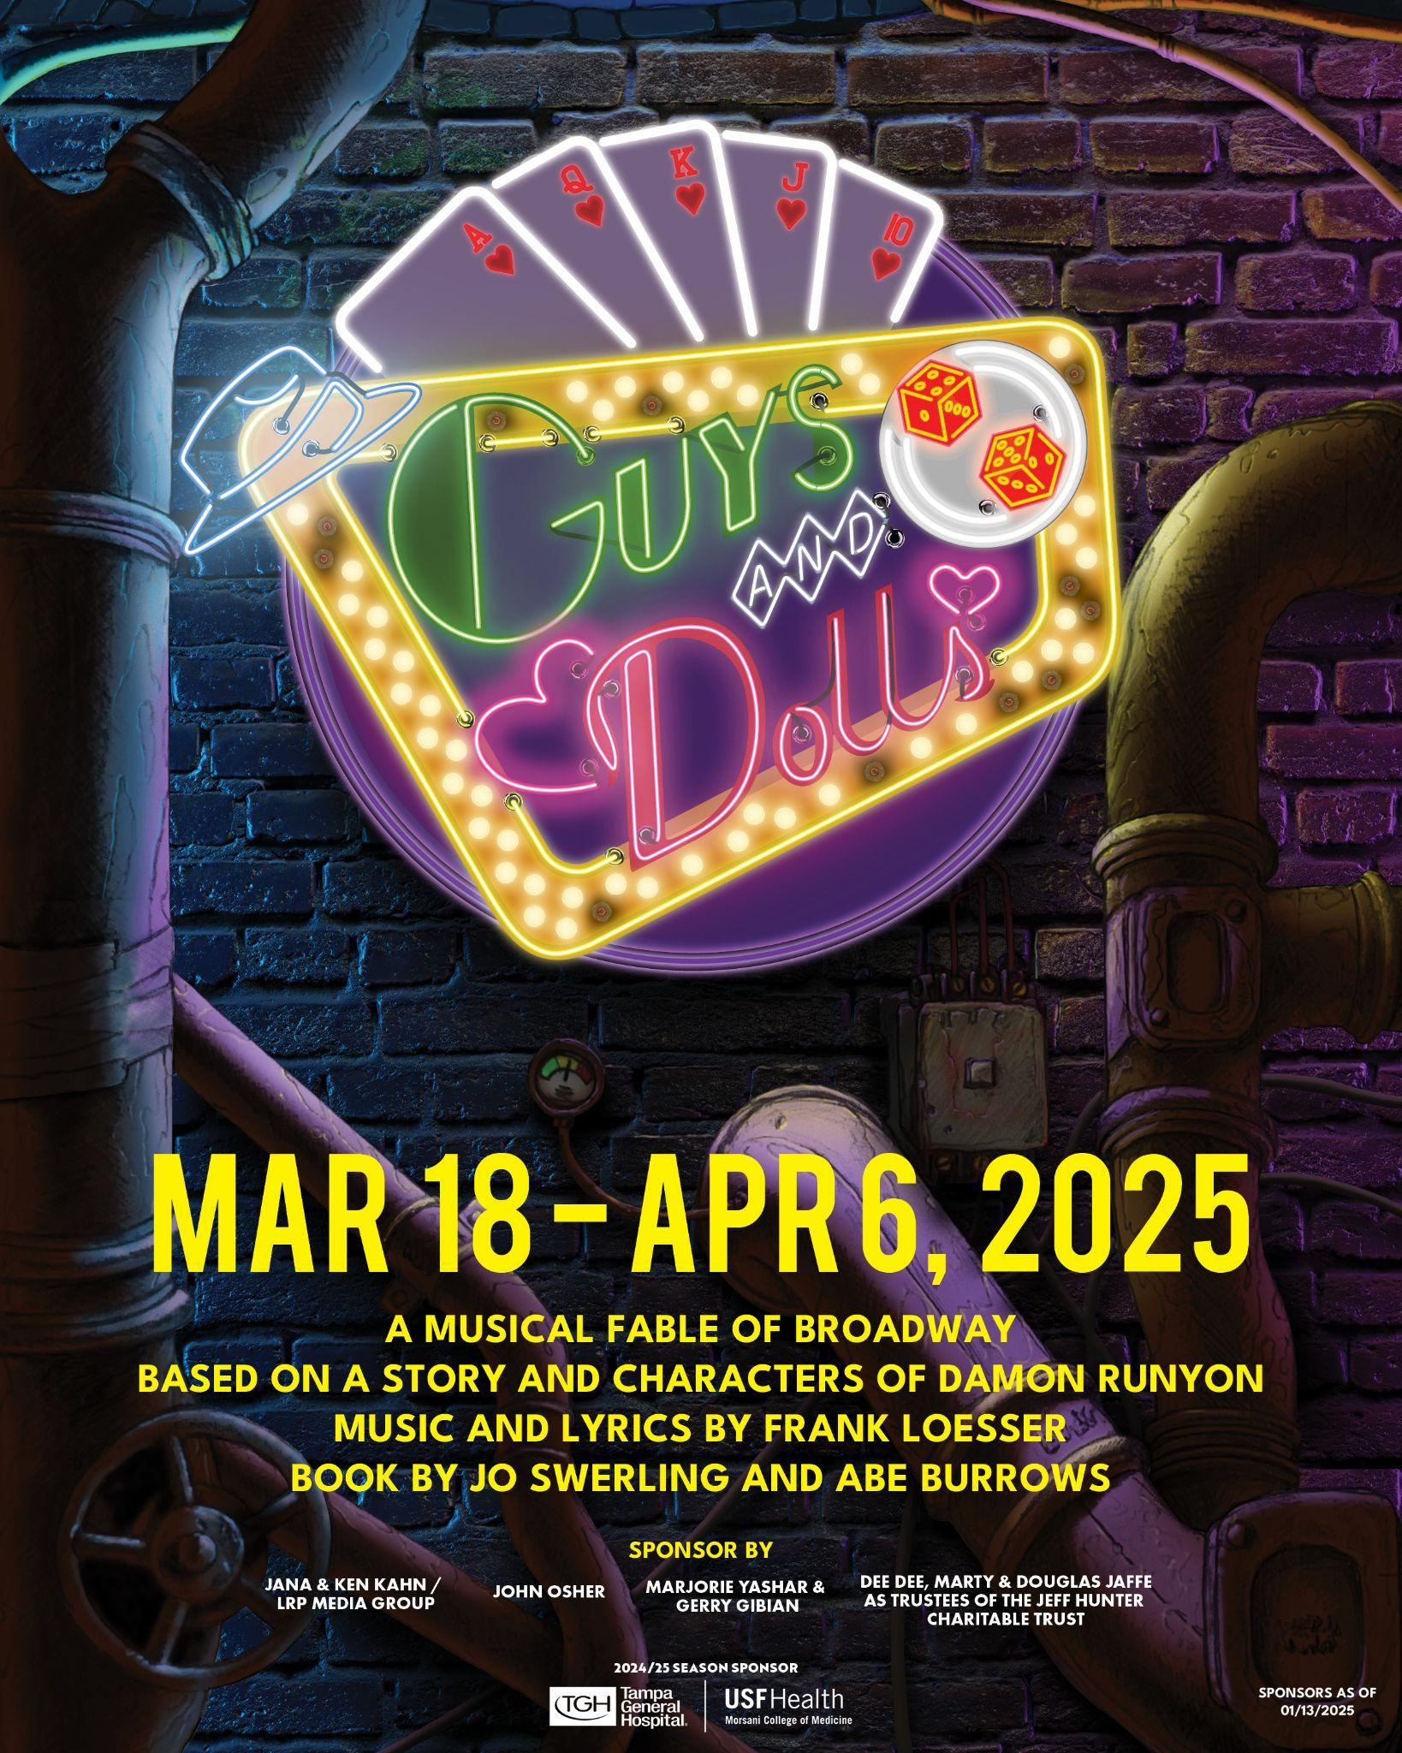

**Andrew Kato**, Producing Artistic Director and Chief Executive, has chosen to revisit this musical masterpiece, which was part of his inaugural season in 2005. “*Guys and Dolls* holds a special place in my heart,” says Kato. “I’m excited to bring a fresh, vibrant, and even more spectacular vision of this show to our audiences.”

This captivating musical seamlessly combines romance, comedy, and high-stakes gambling in the bustling streets of New York City. This timeless production, filled with memorable characters and catchy tunes, transports audiences to a world of colorful personalities and unexpected love stories.

The story follows the intertwining stories of two couples in New York City. Nathan Detroit, a small-time gambler, is desperately trying to find a location for his illegal craps game. To secure the funds, he makes a bet with Sky Masterson, a high-rolling gambler. Sky must convince Sarah Brown, a prim and proper missionary, to go on a date with him to Havana, Cuba.

Meanwhile, Nathan's long-time fiancée, Adelaide, a nightclub performer, is growing tired of their prolonged engagement. As the characters navigate their relationships and personal struggles, they learn valuable lessons about love, trust, and the importance of taking risks.

This production will be Directed and Choreographed by Emmy-Award Winning Choreographer, **Al Blackstone**, returns to the Maltz Jupiter Theatre after choreographing *West Side Story* in 2019 and *Newsies* in 2017. Blackstone’s extensive resume spanning from screen to stage lends itself perfectly to this dance heavy show, with famous numbers like “The Crapshooter’s Ballet.” He will be assisted by Associate Choreographer, **Melissa J. Hunt**, also a member of the ensemble.

This new production boasts significant enhancements, including a talented cast of 19, a 10-piece orchestra led by **Eric Alsford**, and multi-location scenery sets that will transport audiences from the streets of New York to the cafes of Havana. High-tech Video Projections will add to the immersive experience in the scenic design by **Adam Koch** with engaging imagery by Projection Designer **Steve Royal**. Bringing 1930’s New York City style to life is Costume Designer **Johanna Pan** and Associate Costume Designer, **Dan Hewson**, creating the classic suits and fedoras to each and every gambler, and period wigs for every “doll” by **Kevin S. Foster II**. The textured, colorful lighting of the big city will be created by Lighting Designer, **Dalton Hamilton**, and city soundscape from Sound Designer, **Scott Stauffer**. The stage management team will be led by Production Stage Manager, **Kent Collins**, and Assistant Stage Managers, **Randall Swinton** and **Grace Cirillo**.

The talented cast features **Barrett Riggins** as Nathan Detroit, a gifted actor in the art of comedy, who previously worked with Al Blackstone in *An American in Paris* at Cape Playhouse.

**Mallory Newbrough** will play Miss Adelaide, who is a two-time Carbonell Award Winner, seen in previous productions at the Maltz Jupiter Theatre such as *Dracula: A Comedy of Terrors*, *South Pacific*, and *Murder On The Orient Express*. **Dan Deluca** will play Sky Masterson, previously performing as Jack Kelly in the First National Tour of Disney’s *Newsies* and the title role in Jerry Lewis & Marvin Hamlisch’s *The Nutty Professor: The Musical*. **Haile Ferrier** returns to the character of Sarah Brown, who was actually her first professional acting role, as well as recently playing Zoe in the First National Tour of *Dear Evan Hansen*.

**Kyle Taylor Parker** will wow you with his powerful voice as Nicely Nicely Johnson, who performed in *Kinky Boots* on Broadway as well as Jesus *Christ Superstar Live in Concert* on NBC alongside John Legend and Sara Bareilles. And Big Julie will be played by **Jen Cody**, who was in Maltz Jupiter Theatre’s production of *Dirty Rotten Scoundrels* and the voice behind the iconic, Lottie, in Disney’s *The Princess and The Frog.*

**Troy Stanley** makes his return to the Maltz Jupiter Theatre after *West Side Story* as Lt. Brannigan and **Curt Denham** after *A Christmas Story*, as Arvide Abernathy. **Adam Lendermon** will play Benny Southstreet, recently featured in Ryan Murphy’s *Actor: American Horror Story.* Additional cast members include **Colleen Pagano** as Ensemble/General Matilda B. Cartwright, **Michael Santomassimo** as Ensemble/Angie the Ox/Dance Captain, **Giorgio Volpe** as Ensemble/Waiter in Havana, **Keven Quillon** as Ensemble/Harry the Horse, **Maria Cristina Posada Slye** as Ensemble/Sarah Brown Understudy, **Jacquez Linder-Long** as Ensemble/Rusty Charlie/As Cast/Sky understudy, **Torie D'Alessandro**, **Cat Pagano**, **Melissa J. Hunt**, and **Jay L. Johnson**.

With its energetic dance numbers and witty dialogue, *Guys and Dolls* promises an unforgettable experience for theater enthusiasts of all ages. Whether you're a fan of classic Broadway or simply seeking an evening of entertainment, this beloved musical offers a delightful escape into a bygone era.

**MAINSTAGE LIMITED ENGAGEMENTS**

There are just a few MainStage Limited Engagements left in the 2024/25 Season. This includes:***A Tribute to Dolly*** (March 4: 7:30pm)*,* ***Stayin' Alive - One Night of the Bee Gees***(March 5: 7:30pm)*,* ***How Sweet It Is! Steve Leslie sings James Taylor***(March 6: 7:30pm)*,* and ***Forever Motown***(March 7: 5pm, 7:30pm).

**THE ISLAND THEATRE**

We finalize our first season in The Island Theatre with ***Who’s Afraid of Virginia Woolf*** (April 22 - May 4) a Contemporary American Theatre classic by Edward Albee.

There are also a few Island Theatre Limited Engagements left including the 11th Annual Broadway’s Best Benefit Concert, ***Mama I’m A Big Girl Now!***(March 8: 8pm) starring Tony Award® Winner Marissa Jaret Winokur and Tony Award® Nominees Kerry Butler and Laura Bell Bundy. Also,  ***Love Finds Judy Garland*** *(*March 14: 5pm, 8pm) and ***Show Stoppers! Starring Avery Sommers* (**March 15: 8pm)

**2025/26 MAINSTAGE SEASON**

We’ve announced our 2025/26 Season “Broadway’s Bright Lights,” which includes: ***Misery*** (October 26 - November 9), ***Million Dollar Quartet*** (December 2 - December 14), ***Come From Away*** *to be announced on March 3rd (January 6 - January 25), ***Good Night, Oscar*** (February 15 - March 1), and ***Man of La Mancha*** (March 17 - April 5). Season subscriptions are on sale now, and single tickets go on sale in August.

Season subscribers are able to take advantage of discounted ticket pricing with a potential discount of up to 23% off the Theatre’s average single ticket price. In addition to receiving a discount, subscribers keep their great seats for each season production; plus, they receive advance ticket exchanges and purchasing power one week prior to single tickets going on sale to the public. New subscribers can fill out a subscription form at the Theatre’s box office or visit the Theatre’s website to download a subscription form at:  [www.jupitertheatre.org/season-subscriptions](http://www.jupitertheatre.org/season-subscriptions).

**Ticket Information**

To purchase tickets for all shows, visit Maltz Jupiter Theatre’s website at: [www.jupitertheatre.org](http://www.jupitertheatre.org/) or stop by the Box office located at: 1001 Indiantown Rd., Jupiter, FL or call: (561) 575-2223. The Box Office is open weekdays between 10am – 6pm and Saturdays from 10am – 2pm. For group tickets, (20 or more), email: [sales@jupitertheatre.org](mailto:sales@jupitertheatre.org).

**About the Maltz Jupiter Theatre**

The not-for-profit Maltz Jupiter Theatre has become one of Florida’s preeminent professional regional theatres, committed to production and education through its collaborations with local and national artists. Currently a member of the prestigious League of Resident Theatres, the Maltz Jupiter Theatre draws 100,000 patrons annually, serves a subscription base of more than 7,200, and provides performing arts education to both youth and adult students through its Goldner Conservatory. The Island Theatre, a new 198-seat, Second Space has been added to the Theatre’s newly renovated 62,000 square foot facility. Maltz Jupiter Theatre has earned numerous Carbonell Awards, South Florida’s highest honor for artistic excellence, including the prestigious Bill Von Maurer Award for Theatrical Excellence and The Ruth Foreman Award. For tickets and to learn more about all we offer, visit: [www.jupitertheatre.org](https://server.jupitertheatre.org/exchweb/bin/redir.asp?URL=http://www.jupitertheatre.org) or contact the Box Office at: (561) 575-2223.

Media Contact:

Miriam Colvin, (561)-781-3038

[mcolvin@jupitertheatre.org](mailto:mcolvin@jupitertheatre.org)